. 1. Write the Boolean expression for each of these relay logic circuits, showing how the output algebraically relates to the inputs.

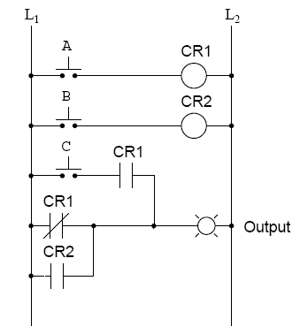
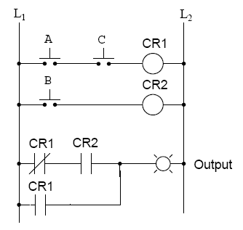

[A] o/p = ___________________ [B] o/p = ___________________

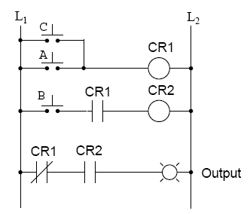
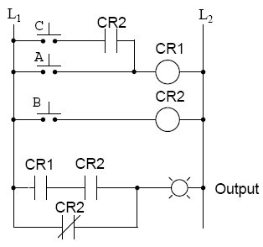

[C] o/p = ___________________ [D] o/p = ___________________

- Use Boolean algebra to simplify the relay logic circuits in problem 1 whenever possible.

[A] o/p = _________________________________________

[B] o/p = ________________________________________

[C] o/p = ________________________________________

[D] o/p = _______________________________________

- Convert the following logic gate circuit into Boolean expression, showing how the output algebraically relates to the inputs.
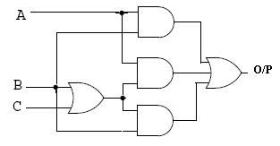
o/p = ___________________

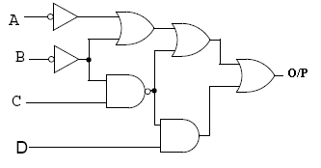

o/p = __________________

- Use Boolean algebra to simplify the logic gate circuits in problem 3 whenever possible.

o/p = ________________________

o/p = ________________________

- Use Boolean algebra to simplify the following expression, then draw a logic gate circuit for the simplified expression using either POS or SOP.

[a] 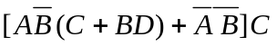
= ___________________

[b]
= ______________________

[c] 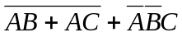
= ___________________

- Write a Boolean SOP expression for this truth table, then simplify that expression as much as possible and draw a logic gate circuit equivalent to that simplified expression.
A | B | C | o/p
0 | 0 | 0 | 1
0 | 0 | 1 | 0
0 | 1 | 0 | 0
0 | 1 | 1 | 1
1 | 0 | 0 | 0
1 | 0 | 1 | 0
1 | 1 | 0 | 1
1 | 1 | 1 | 1

O/P = __________________________

A | B | C | o/p
0 | 0 | 0 | 1
0 | 0 | 1 | 1
0 | 1 | 0 | 1
0 | 1 | 1 | 0
1 | 0 | 0 | 1
1 | 0 | 1 | 1
1 | 1 | 0 | 0
1 | 1 | 1 | 1

O/P = ________________________

A | B | C | D | o/p
0 | 0 | 0 | 0 | 1
0 | 0 | 0 | 1 | 1
0 | 0 | 1 | 0 | 0
0 | 0 | 1 | 1 | 0
0 | 1 | 0 | 0 | 1
0 | 1 | 0 | 1 | 1
0 | 1 | 1 | 0 | 1
0 | 1 | 1 | 1 | 1
1 | 0 | 0 | 0 | 0
1 | 0 | 0 | 1 | 1
1 | 0 | 1 | 0 | 0
1 | 0 | 1 | 1 | 1
1 | 1 | 0 | 0 | 0
1 | 1 | 0 | 1 | 0
1 | 1 | 1 | 0 | 0
1 | 1 | 1 | 1 | 0

O/P = _________________________

A | B | C | D | o/p
0 | 0 | 0 | 0 | 1
0 | 0 | 0 | 1 | 0
0 | 0 | 1 | 0 | 1
0 | 0 | 1 | 1 | 0
0 | 1 | 0 | 0 | 1
0 | 1 | 0 | 1 | 1
0 | 1 | 1 | 0 | 1
0 | 1 | 1 | 1 | 0
1 | 0 | 0 | 0 | 1
1 | 0 | 0 | 1 | 0
1 | 0 | 1 | 0 | 1
1 | 0 | 1 | 1 | 1
1 | 1 | 0 | 0 | 1
1 | 1 | 0 | 1 | 1
1 | 1 | 1 | 0 | 1
1 | 1 | 1 | 1 | 0

O/P = ____________________

- Write a Boolean POS expression for this truth table, then simplify that expression as much as possible and draw a logic gate circuit equivalent to that simplified expression

A | B | C | o/p
0 | 0 | 0 | 0
0 | 0 | 1 | 0
0 | 1 | 0 | 0
0 | 1 | 1 | 0
1 | 0 | 0 | 1
1 | 0 | 1 | 1
1 | 1 | 0 | 0
1 | 1 | 1 | 1

O/P = _________________________

A | B | C | D | o/p
0 | 0 | 0 | 0 | 0
0 | 0 | 0 | 1 | 1
0 | 0 | 1 | 0 | 0
0 | 0 | 1 | 1 | 1
0 | 1 | 0 | 0 | 0
0 | 1 | 0 | 1 | 1
0 | 1 | 1 | 0 | 1
0 | 1 | 1 | 1 | 1
1 | 0 | 0 | 0 | 0
1 | 0 | 0 | 1 | 0
1 | 0 | 1 | 0 | 1
1 | 0 | 1 | 1 | 1
1 | 1 | 0 | 0 | 0
1 | 1 | 0 | 1 | 1
1 | 1 | 1 | 0 | 1
1 | 1 | 1 | 1 | 1

O/P = ______________________

- Write an SOP expression for this truth table, and then draw a ladder logic (relay) circuit diagram corresponding to that SOP expression.

A | B | C | D | o/p
0 | 0 | 0 | 0 | 1
0 | 0 | 0 | 1 | 0
0 | 0 | 1 | 0 | 1
0 | 0 | 1 | 1 | 1
0 | 1 | 0 | 0 | 1
0 | 1 | 0 | 1 | 0
0 | 1 | 1 | 0 | 1
0 | 1 | 1 | 1 | 0
1 | 0 | 0 | 0 | 1
1 | 0 | 0 | 1 | 0
1 | 0 | 1 | 0 | 1
1 | 0 | 1 | 1 | 1
1 | 1 | 0 | 0 | 1
1 | 1 | 0 | 1 | 0
1 | 1 | 1 | 0 | 1
1 | 1 | 1 | 1 | 0

O/P = _____________________

A | B | C | o/p
0 | 0 | 0 | 1
0 | 0 | 1 | 1
0 | 1 | 0 | 0
0 | 1 | 1 | 1
1 | 0 | 0 | 1
1 | 0 | 1 | 1
1 | 1 | 0 | 0
1 | 1 | 1 | 0

O/P = __________________

- Use De Morgan’s Theorem, as well as any other applicable rules of Boolean algebra, to simplify the following expression so there are no more complementation bars extending over multiple variable.

[a] 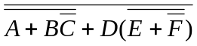 = ________________________________

[b] 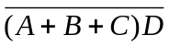 = ____________________________________

[c] 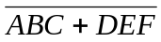 = ____________________________________

[d] 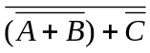 = ___________________________________

[e] 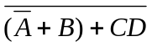 = _________________________________

[f]   

